# Introduction

There are many factors that determine the value of a home in the real estate market. We have been provided a dataset containing explanatory variables and the final sale prices of homes. We will attempt to predict the final sales price of a home for Ames, Iowa using multiple linear regression.

# Data Description

The data was provided from the following educational kaggle competition:

<https://www.kaggle.com/c/house-prices-advanced-regression-techniques/data>

The data consists of 79 explanatory variables and the final Sales Price of a home in Ames, Iowa. The [Ames Housing dataset](http://www.amstat.org/publications/jse/v19n3/decock.pdf) was compiled by Dean De Cock for use in data science education.

For analysis question 1, we are only interested in the following variables:

GrLIvArea

SalesPrice

Neighborhoods (NWAmes, Edwards and BrkSide specifically)

For analysis question 2, the best model we calculated, from a forward model, had the following variables:

OverallQual defined as the rating of the overall material and finish of the house.

GrLivArea defined as the above grade ground living area square feet.

Neighborhood defined as the physical locations of all neighborhoods within the Ames city limits.

BsmtQual defined as the height of the basement.

The variables OverallQual, Neighborhood, and BsmtQual are categorical variables and the following table shows the different categories for each variable.

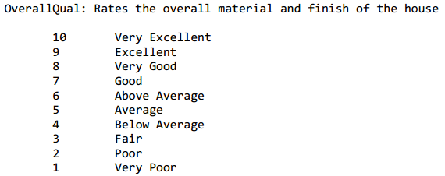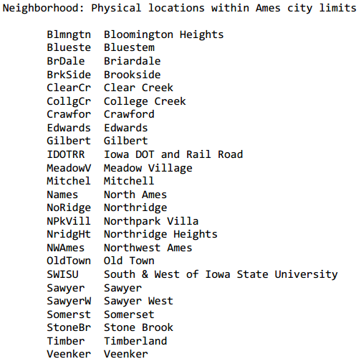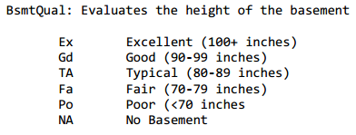

# Analysis Question 1:

## Restatement of Problem

Century 21 Ames only sells houses in the NAmes, Edwards and BrkSide neighborhoods and would like to simply get an estimate of how the SalePrice of the house is related to the square footage of the living area of the house (GrLIvArea) divided by 100 and if the SalesPrice (and its relationship to square footage) depends on which neighborhood the house is located in.

## Build and Fit the Model

**The following model was built using glm regression based on the variables stated above and diagnosis of fit and assumption checking is also provided (code referenced in Appendix).**

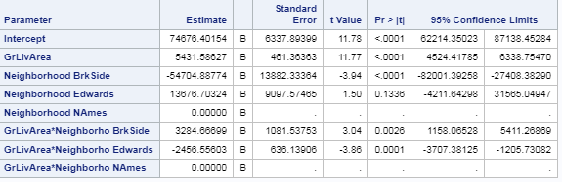

|  |  |
| --- | --- |
|  | Note that the Edwards neighborhood regression line seems to be heavily influenced by two points with a GrLivArea greater than 30. |

## Checking Assumptions

|  |  |
| --- | --- |
|  | **Normality:** The data appears to be normal given the bell shaped distribution in the histogram highlighted in the red box of illustration. We also see evidence of normality in the qqplot in the red box as well.  **Linear Trend:** The pairwise scatter plot in orange box indicates a strong linear trend.  **Equal SD:** There is little evidence from the scatter plots of heteroscedasticity and the Residual plot in the blue box shows a nice random cloud.  **Independence:**  We will assume the observations are independent.  **Influential point analysis:**  We see that we have two points circled in green that have high leverage over the rest of the data. I believe these are the points above 30 in GrLivArea.  Also, we see that the Cook’s D has a very high point, circled in purple, at 2.5 that is concerning. Therefore, we decided to take out these two points. |

## Comparing Competing Models

In the model with the two influential points, the adjusted r-square of the model is 0.44. However, once the two influential points are taken out from the data set, the model adjusted r-square increased to 0.4975. Therefore, the fit of the model has increased because there are no outliers in the data set. The fit statistics shown below is the same model above without the two influential points.

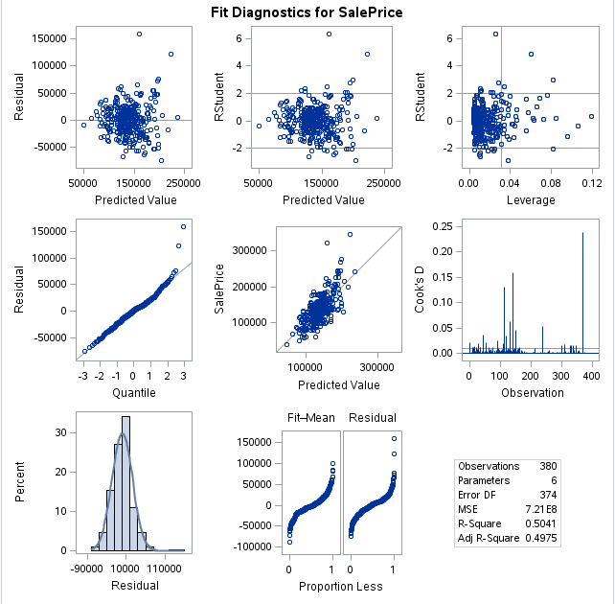

As can be shown, the Cook’s D does not show any high out of range values, and the leverage graph indicates no specific values that are out of range. When examining the two outlier points, the sales price of the house is low for the given square footage. It is possible that these houses could be a foreclosure or maybe the location of the house is not ideal, however without further information we cannot make any conclusive reasoning as to why these points are outliers.

## Parameters

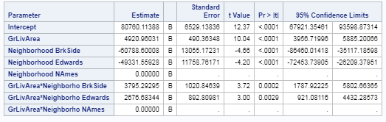

As we can see, all variables in the model are significant at the 95% confidence level. The GrLivArea indicates that for every 100 sqft increase in the greater living area leads to a $4920.96 increase in the sales price, holding all else equal. Given that the range of values for this effect at the 95% confidence level is between 3956.72 to 5885.20. When looking at the neighborhoods, we see that when BrkSide is compared with NAmes, we see that the price decreases by $60788.60 with a given range at the 95% confidence level of 86460.01 to 35117.19, holding all else equal. When we are comparing Edwards to Names, we see that the price decreases by $4933.56 with a given range at the 95% confidence level of 72453.74 to 26209.38, holding all else equal. When looking at the interaction effects between the neighborhood and GrLivArea, we can see that there are differences. Looking at the interaction with BrkSide, we see that for every 100 sqft increase in this area compared to NAmes will lead to an increase in SalesPrice of 3795.29 with a range at the 95% confidence level of 1787.92 to 5802.66, holding all else equal. Looking at the interaction with Edwards, we can see that for every 100 sqft increase in this area compared to NAmes will lead to an increase in SalesPrice of 2676.68 with a range at the 95% confidence level of 921.08 to 4432.29, holding all else equal.

## Conclusion

By looking at the model, we can see that when comparing prices, holding all other variables equal, NAmes is priced higher when compared to the other two neighborhoods. However, when looking at the square footage of the living area, we can see that having a larger living area in Edwards and BrkSide will lead to a higher sales price when compared to NAmes, holding all other variables equal. Therefore, for determining the Sales price of the house, the neighborhood is a good determining factor with square footage coming a close second.

# Analysis Question 2

## Restatement of Problem

We would like to build the most predictive model for sale prices of homes in all of Ames Iowa given the 79 variables in the data set to determine which model is considered of best fit.

## Model Selection

We built four models with different methods of selecting important variables. The following models were completed:

* + - * Stepwise
      * Forward
      * Forward without Outliers
      * Backward
      * Custom

## Comparing Competing Models

The results of the above model selection are shown below, and the forward/stepwise model seems to show the most promise of being the best model from our analysis. Please see appendix for final model.

|  |  |  |  |
| --- | --- | --- | --- |
| **Predictive Models** | **Adjusted R2** | **CV PRESS** | **Kaggle Score** |
| Forward Model | 0.8068 | 1848 | .18533 |
| Forward Model with No Outliers | 0.9071 | 9188 | .28203 |
| Backward Model | .9212 | 4079 | 1.35659 |
| Stepwise Model | .8068 | 1842 | .18533 |
| Custom Model | .8096 | 2.09309E12 | .24487 |

## Checking Assumptions

|  |  |
| --- | --- |
|  | **Normality:** The data appears to be normal given the bell shaped distribution in the histogram.  **Linear Trend:** The pairwise scatter a strong linear trend.  **Equal SD:** There is little evidence from the scatter plots of heteroscedasticity and the Residual plot shows a nice random cloud.  **Independence:**  We will assume the observations are independent.  **Influential point analysis:**  We see that we have two points that have high leverage over the rest of the data. When influential points were removed, we noticed it negatively reduced our kaggle score so we are leaving them in.  There 1 pretty high cooks d, but we left it in for a better kaggle score as explained above. |

## Conclusion: A short summary of the analysis.

After completing the Forward, Backward Model, and Stepwise model with outliers, we created a custom model by getting results (p-values) from the other models and chose variables that were extremely significant. Once we had all four models completed, we submitted to kaggle to determine which model had the best kaggle test score to focus on that model. The forward model seemed to have the best score. We then evaluated the assumptions and outliers and removed outliers from the training set, but found that the kaggle score decreased so we are going with the original Forward Model including all the data.

# Appendix

## Question 1 Code:

/*

* Import the Training Data Set

*/

PROC IMPORT OUT= WORK.train

DATAFILE= "/home/marinfamily1010/sasuser.v94/Data/train.csv"

DBMS=CSV REPLACE;

GETNAMES=YES;

DATAROW=2;

RUN;

proc sql;

create table work.train3 as

/*Dividing the GrLivArea by 100*/

select Neighborhood, GrLivArea/100 as GrLivArea, SalePrice

from train

where Neighborhood in ('NAmes','Edwards','BrkSide')

order by Neighborhood;

run;

/*

* At least one neighborhood has a different slope. Using Different slopes model.

*/

proc sgscatter data = work.train3;

by Neighborhood;

plot SalePrice * GrLIvArea;

run;

proc glm data = work.train3 plots = ALL;

class Neighborhood (ref = "NAmes");

model SalePrice = GrLIvArea | Neighborhood / solution clparm;

output out = cookd cookd = cookd;

run;

/*Limiting the high cookd value and the high leverage points out of data (influential points)*/

proc sql;

create table work.train4 as

select Neighborhood, GrLivArea as GrLivArea, SalePrice

from COOKD

where Neighborhood in ('NAmes','Edwards','BrkSide')

and cookd < 2.74

and GrLivArea < 30

order by Neighborhood;

run;

/*Re-running scatter and model without influential points*/

proc sgscatter data = work.train4;

by Neighborhood;

plot SalePrice * GrLIvArea;

run;

proc glm data = work.train4 plots = ALL;

class Neighborhood (ref = "NAmes");

model SalePrice = GrLIvArea | Neighborhood / solution clparm;

output out = cookd2 cookd = cookd2;

run;

## Question 2 Code:

PROC IMPORT OUT= WORK.train

DATAFILE= "/home/marinfamily1010/sasuser.v94/Data/train.csv"

DBMS=CSV REPLACE;

GETNAMES=YES;

DATAROW=2;

RUN;

PROC IMPORT OUT= WORK.test

DATAFILE= "/home/marinfamily1010/sasuser.v94/Data/test.csv"

DBMS=CSV REPLACE;

GETNAMES=YES;

DATAROW=2;

RUN;

data work.test;

set test;

SalePrice = .;

;

data work.train2;

set train test;

run;

data work.train1;

set work.train2;

rename '1stFlrSF'n = FirstFlrSF '2ndFlrSF'n = SecondFlrSF '3SsnPorch'n = ThreesnPorch;

run;

options mlogic symbolgen; /**********Options are used to help see the & stuff*************/;

/*******Dealt with missing years for GarageYrBlt and also Converted LotFrontage to Numeric*******************/;

data kaggle;

set work.train1;/*Update to your imported data set*/

if LotFrontage ne "NA" then LotFrontage_clean = input(lotfrontage,8.);

if GarageYrBlt = . then GarageYrBlt = YearBuilt;

drop LotFrontage;

run;

/********This code replaces the missing data for LotFrontage_clean and MasVnrArea with the Median

Value**********************/

proc stdize data=kaggle out=kaggle_clean method=median missing=median reponly;

var LotFrontage_clean MasVnrArea;

run;

/*Note in analysis 2 there were three variables that had missing observations, and so some estimations were used to calculate the missing observations. For the variable GarageYrBlt, this variable is defined as the year the garage is built for the house. For the observations missing, the YearBuilt is used as the proxy for the missing observations. The variables LotFrontage_clean and MasVnrArea describes the square footage of certain aspects of the property, and so a median value of the data field is used as the proxy for the missing variables. */

/********************A way to check for missing data*************************/;

proc contents data=kaggle_clean out=contents;

run;

/*************Pulls all the variables names that are categorical*****************/;

proc sql;

select name into: variables separated by " " from contents where format ="$";

quit;

/**************Pulls all the variable names that are numerical*****************/;

proc sql;

select name into: numerical separated by " " from contents where (format ne"$" and name ne "Id");

quit;

/**********************Pulls all variable names except ID and SalePrice*************/;

proc sql;

select name into: modelvariables separated by " " from contents where (name ne "Id" and name ne "SalePrice");

quit;

%put &variables;

/*************Raw Data Set**************************************/;

/*******************Looks at the Frequency count for categorical Variables***************/;

proc freq data=kaggle;

table &variables;

run;

/*******************Looks at some of the summary numbers for the numerical variables**********/;

proc means data=kaggle n nmiss mean median std;

var &numerical;

run;

/********************Cleaned Data Set***************************/;

/*******Follows the same as above for check*********************/;

proc freq data=kaggle_clean;

table &variables;

run;

proc means data=kaggle_clean n nmiss mean median std;

var &numerical;

run;

/**************The forward, backward, and stepwise selection*******************/;

proc glmselect data=kaggle_clean plots(stepaxis = number) = (criterionpanel ASEPlot);

class &variables;

model SalePrice = &modelvariables / selection=forward(stop=CV) cvmethod=random(5) select = sl slentry = .1

stats=adjrsq;

output out = results p = Predict;

run;

proc glm data = kaggle_clean plots=all;

class &variables;

model SalePrice = OverallQual GrLivArea Neighborhood BsmtQual / solution clparm;

run;

data forward_model;

set results;

if Predict > 0 then SalePrice = Predict;

if Predict < 0 then SalePrice = 10000;

keep id SalePrice;

where id > 1460;

proc glmselect data=kaggle_clean ;

class &variables;

model SalePrice = &modelvariables / selection=backward(stop=CV) cvmethod=random(5) select = sl slstay = .1 stb showpvalues

stats=adjrsq;

output out = results1 p = Predict;

run;

data backward_model;

set results1;

if Predict > 0 then SalePrice = Predict;

if Predict < 0 then SalePrice = 10000;

keep id SalePrice;

where id > 1460;

;

proc glmselect data=kaggle_clean;

class &variables;

model SalePrice = &modelvariables / selection=stepwise(stop=CV) cvmethod=random(5) select = sl slentry = .1 stb showpvalues

stats=adjrsq;

output out = results2 p = Predict;

run;

data stepwise_model;

set results2;

if Predict > 0 then SalePrice = Predict;

if Predict < 0 then SalePrice = 10000;

keep id SalePrice;

where id > 1460;

;

proc glmselect data=kaggle_clean ;

class &variables;

model SalePrice = BedroomAbvGr BsmtFinSF1 BsmtFinSF2 BsmtFullBath BsmtUnfSF Fireplaces FirstFlrSF FullBath GarageArea GarageCars GrLivArea KitchenAbvGr LotArea LotFrontage_clean LowQualFinSF MSSubClass MasVnrArea MoSold OverallCond OverallQual PoolArea ScreenPorch ThreesnPorch TotRmsAbvGrd WoodDeckSF YearBuilt YearRemodAdd YrSold / selection=backward(stop=CV) cvmethod=random(5) select = sl slstay = .01 stb showpvalues include = 28

stats=adjrsq;

output out = results3 p = Predict;

run;

data custom_model;

set results3;

if Predict > 0 then SalePrice = Predict;

if Predict < 0 then SalePrice = 10000;

keep id SalePrice;

where id > 1460;

;

Models output for Stepwise, Forward, Forward without Outliers, Backward, and Custom

* + - * Stepwise

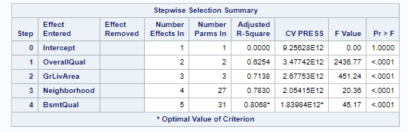

* + - * Forward

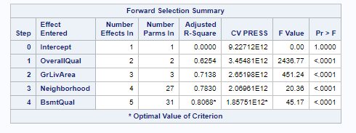

* + - * Forward without Outliers



* + - * Backward

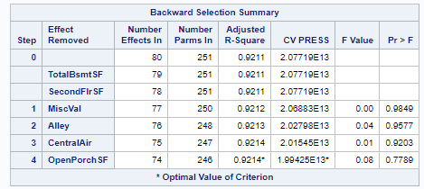

* + - * Custom

The parameter estimates of the Forward/Stepwise model

